Chapter 3 for publication

Title: Invasivity on an island gradient: measuring the current and future invasive spread of Ficus religiosa three Hawaiian Islands (Kauaʻi, Oʻahu, Big Island of Hawaiʻi).

Authors: Jazlee Crowley, Ronan Davis, Brenna R Prevelige, Dana K Howe, Dee Denver

Audience: 1) Invasive Species Biologists 2) Ethnobiologists

Aims:
- Measure current level of F. religiosa invasion on three separate islands in Hawaiʻi. Measure difference in invasive levels across three islands, within one island (Kauaʻi) across three years, and compare to native region in Nepal.
- Measure potential habitat and spread across the three islands, particularly with consideration of rising global temperatures.
- Consider cultural reasons for introduction and spread of F. religiosa, and propose management solution by involving non-academic stakeholders throughout research process and execution.

Timeline:
March: Finish Outline of Methods, Results and Figures; Start outline of entire paper
April: Finish paper outline; Start first complete rough draft
May: Finish first rough draft and send to Dee, then to collaborators; Start final edit
June: Finish final edit; start and end submission process

Wordcount: ~5,000

Acknowledgments (need some last names and specifics): Jerry Hirata, Reverend Jiko, Kauaʻi Soto Zen Temple Zenshuji community, Big Island Temple community, Sam, National Tropical Botanical Garden, Hindu Temple and Monk, Botanical Garden, Sharon, Oshibana art group, Hirut Denver, Peace Garden in Kauaʻi, Emily Taylor, Christopher Marshall, Greg Levine, Sulochana Wasala, Clara Wheeler, Bryan Lynn.

Writing Order:

Methods
Results
Intro
Discussion
Abstract

Methods

Tree Location
To locate each adult tree on the islands a variety of methods were employed, including locating through iNaturalist, temples, botanical gardens, public data from Hawaiian invasive species committees, word of mouth, and opportunistic findings.
iNaturalist (cite), a citizen science app, has been found to be highly effective in aiding the measurement of biodiversity and species location research in the past five years (Mason et al 2025). We examined every F. religiosa hit on iNaturalist across the the three islands, first examining for legitimacy and habitat. This culled entries that included unattached leaves from trees, or the occasional potted indoor plant. All seemingly legitimate entry locations were saved to be investigated through field work.
Because of their religious importance, Bodhi trees are most often planted at Buddhist, and occasionally Hindu, temples. They are also considered ornamentals, and thus are found in nurseries and botanical gardens as well. Before fieldwork we went through every temple, nursery and botanical garden website on the island, with possible follow up phone calls, to locate additional trees on those properties. All individuals that claimed to have a Bodhi tree were added to the the saved locations to be investigated through field work.
Various Hawaiian invasive species councils have documented the arrival and location of F. religiosa on the islands as well, particularly in Kauaʻi. By utilizing the Kauaʻi Invasive Species Committee article published detailing the location of adult Bodhi trees, we were able to add any additional Bodhi tree locations not found through the above methods (cite). Additionally, word of mouth in the community during field work also led us to two adult trees.

Field Survey Methods
For each adult tree located we administered a similar protocol. All surveying was completed only after obtaining permission from the owner or care taker of the location when appropriate (in the cases of temples and botanical gardens). Each adult’s geolocation was saved, followed by the research team searching thoroughly for offspring, walking up to 2 km away in every direction from the adult tree. All discovered offspring were also geolocated, and each plant had one leaf sampled for genetic verification of parent/offspring relationship. Occasionally offspring were found without a nearby adult being identified, specifically on the island of Oʻahu. In this case geolocation was still taken, though was not attached to an adult.
All trees were classified as thus: if <1 meter tall, seedling; if >1 meter tall and Diameter at Breast Height (DBH) is 5-10cm, sapling; if >1 m tall and DBH is >10, adult.
This process was executed on Kauaʻi three years in a row, from 2023 to 2025. Every year the same survey process was repeated, taking into account when possible which offspring were new that year and which were present the year before. Oʻahu and the Big Island were surveyed only in 2025, in the same manner.
Data Analysis
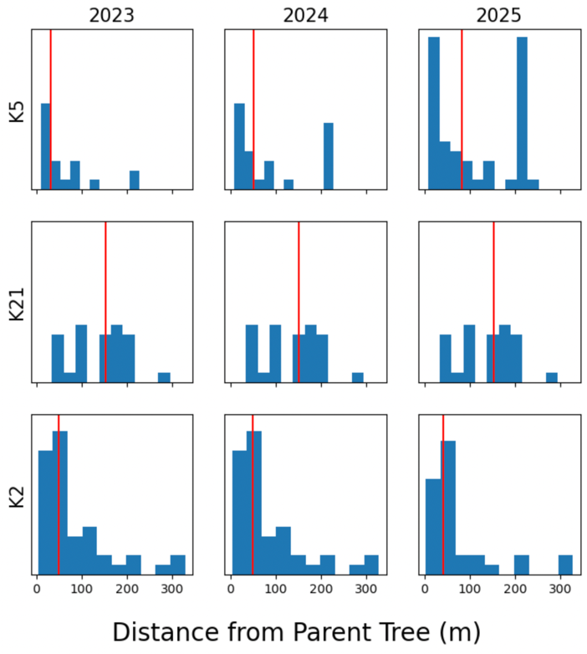
All tree locations were saved in GoogleEarth (cite). In Kauaʻi there were three reproducing adult trees, labeled K2, K21 and K5. Distance from adult tree to offspring was measured each year in Kauaʻi (Fig?), where parentage could be guarateed. Parentage was assigned through two methods: statistically through K-Nearest neighbor and genetic verification. Leaves were kept in leaf press and were later stored in a refrigerator in Ziploc bags at 3
Fig ?. Histogram showing offpsring amount and spread from parent tree across three years. Median lines included in red.
degrees Celsius. How thoroughly should I describe our DNA extraction/analysis process? Is there a way we can mention pollinators without opening a new can of analysis worms?

Three sets of Analysis
I would like to compare both the number of offspring and spread of offspring from a single adult within each island, across three islands in one year, and within one island (Kaua’i across three years. This will illustrate whether or not there is a significant increase in naturalizing offspring on the islands, and which islands are impacted the most. It will also show whether or not there are differences in naturalization success between individual trees on Kauaʻi

Assessing Potential Range Expansion
MaxENT (Phillips, 2017) was used to model niche species distribution potential in invasive areas, and note where actual individuals are and the potential areas on the island the species may spread in the future. Conditions considered for this data include future projections of global warming. This data will be curated to include a 50 meter range to allow for slight geomarker error.
To measure invasive density, we used nested fixed radius plot to measure invasive tree density

MaxENT
In order to render GoogleEarth files usable to MaxENT (cite), QGIS (cite) was used to convert data into correct file types. Environmental layers information was downloaded from Worldclim (cite). Downloaded layers from Worldclim included:

Results
Kauaʻi over three years
Adults to themselves: Kruskal-Wallis, no significance, though consistent
Fixed Radius plots
Nested Subplots—for regeneration. Ask Chat how to do nested subplots in R
Using a nested fixed radius plot to measure invasive tree density
Centering at adults for “adult influence on regeneration”
Center at a random point for “invasive species density across area”
Need Adults to eachother
Cross Island Comparison
Still figuring out how to find this
Comparison to Native range
Need iNaturalist data from Nepal, Kathmandu. “We compared to city centers for these justifiable reasons”.
Potential Range with MaxENT
Working on this currently

Introduction
The native flora and fauna of the Hawaiian Islands have become increasingly threatened due to invasive species spread through the past several decades (Gillespie et al 2008). While non-native species may be introduced for a variety of reasons, the newly introduced Bodhi tree (Ficus religiosa) is quite unique for its historical ties to Hinduism and especially Buddhism. The Bodhi tree is said to be the tree that Buddha gained enlightenment beneath about 2,600 years ago, and has been held in great sanctity in the religion ever since. As Buddhism globalized so did the Bodhi tree, and has now been introduced to several non-native regions (cite) outside of central and South-East Asia (Chen et al 2021). One of these regions is the Hawaiian Islands, with the first Bodhi tree arriving with Buddhism around the turn of the century (cite).
Talk about invasive species spectrum and definitions. Introduction of pollinator has only hastened this progression. However, the naturalized realm is a compelling place to do research (Richardson and Pycek)
Discussion
Three Islands, Three Invasive Stories
Discussing label process and why.
Future management and impacts
Include MaxENT discussion and community aid.

Abstract
The globalization of Buddhism has aided in the diaspora of the Bodhi tree to non-native regions of the world, including the non-native region of the Hawaiian Islands. To determine the invasive threat of the Bodhi tree the Hawaiian Islands, I will conduct an analysis tree growth and spread across Kauaʻi, the Big Island and Oʻahu, spending three field seasons in Kauaʻi and one in the subsequent two islands. I will compare the rate of species invasion, and show that there is a wide difference across the three islands. I will show the invasive potential in future years using maxent, and propose management methods that consider non-academic stakeholders.

Citations
Maxent
Worldclim
QGIS
Area of islands: "Table 5.08 – Land Area of Islands: 2000" (PDF). State of Hawaii. 2004. Archived from the original (PDF) on March 9, 2013. Retrieved July 23, 2007.
Area of Honolulu: US census bureau
